What is joint action?

1. Shared intention (philosophers’ standard approach). On this view, a joint action is an action guided by a shared intention. I think Guenther and Natalie endorsed this view in one paper, although it differs from their official view.

Philosophers have given strikingly different accounts of what sharing an intention amounts to. John Searle and Christopher Kutz hold that shared intentions are intentions of a special kind—they differ from individual intentions with respect to the attitude involved (collective intentions for Searle, participatory intentions for Kutz); Michael Bratman argues that shared intention is not a special kind of attitude but rather involves intentions whose contents interlock in a special way; Margaret Gilbert held that individual differ from shared intentions because the subject of a shared intention is a plural subject; relatedly, she and others have held that the characteristic feature of shared intention is that it involves obligations or commitments to others; and opposing all of these views, Natalie Gold and Robert Sugden have recently argued that shared intentions are distinctive not in their nature or contents but in being produced by a certain kind of reasoning, team reasoning [see #7].

Minor objection: I think this approach is too limited to cover all the cases that are scientifically interesting. E.g. the conjecture that one becomes able to understand intentions and commitments through engaging in joint action may require that not all forms of joint action involve shared intention (although this depends on what sharing amounts to).

Major objection: there doesn’t seem to be any reason to accept that joint action necessarily involves one or another kind of shared intention. It’s not clear why the claim isn’t terminological. Why should the category of joint action not also include shared goals and shared task representations?

This doesn’t mean that action-involving-shared-goals isn’t an interesting and central case of joint action. But it isn’t obviously the only case; and should ask why this case is interesting and central.

2. Shared task representations: Joint action involves sharing either an intention, a goal, a task representation or some other type of action-guiding state. This is an intuitive idea but it sounds more uniform than it really is because talk of “sharing” amounts to different things in each case.

Consider shared task representations. In general, an agent has a shared task representation when:
(i) she represents one or more rules characterising her own part in a task;
(ii) she represents one or more rules characterising another agent’s part in the task; and
(iii) all rules are represented in a functionally equivalent way: that is, the representations of rules in (i) and (ii) alike dispose her to act on these rules.

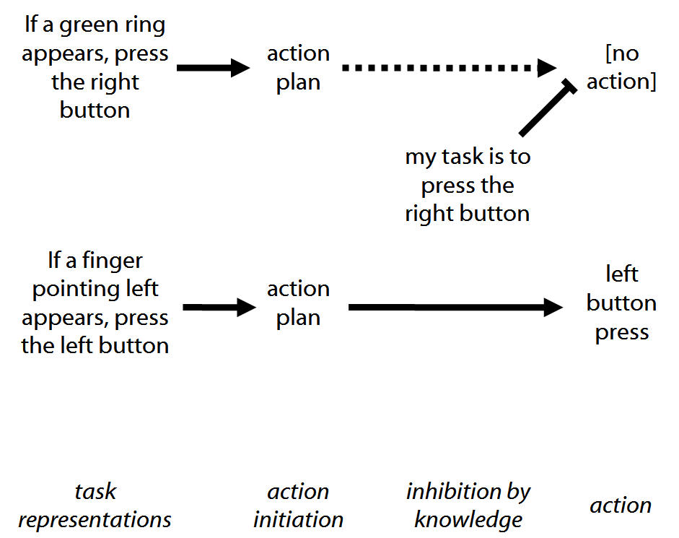

So a shared task representation is not shared in the sense that two people necessarily represent the same task. Rather, what’s shared is the type of vehicle that a single person uses to represent both her own and her partner’s role in a task.

Note that shared task representations are not essentially reciprocal. So:

Ayesha and Tim have shared task representations  =  Ayesha has a shared task representation and Tim has a shared task representation | Ayesha and Tim moved the table together  !=  *Ayesha moved the table together and Tim moved the table together

3. Reciprocity and non-distributive plural predication. For an indication of what the distinction between distributive and non-distributive plural predication is intended to capture, contrast ‘The tiny pieces of gravel blocked Jim’s way’ (naturally understood as non-distributive) with ‘The runners completed the marathon’ (naturally understood as distributive). According to Thomas McKay, ‘a predicate F is distributive if the following condition holds in virtue of the meaning of the predicate F: Whenever some things are F, each one of them is F’ (2006: 5)(for other definitions see Linnebo 2005; Oliver and Smiley 2001: 289, 2008: 23).

It seems tempting to think that we can capture the sort of togetherness or sharing that is (perhaps) intuitively required for joint action by appeal to non-distributive plural predication. Two agents, A and B, are engaged in the joint action of F-ing when ‘A and B are F-ing (or F-ed)’ is true and involves non-distributive plural predication {an idea along these lines seems to be endorsed by \Kutz, 2000 #1290@1–2}.

Here are two reasons not to go this way. First, on standard definitions of distributive predication, many of the cases relevant to development are adequately described by sentences involving only distributive predication (such as ‘Tanya and Tim tided the toys’). Second, it seems to me that our current state of knowledge involves uncertainties about how exactly the notion of plural predication should best be characterised—in particular, about whether predicates can be used both distributively and non-distributive, or whether they are ambiguous. There are also uncertainties about what (if anything) the notion reveals about the meanings of predicates and about humans’ everyday abilities to classify activities. Further investigation of plural predication might allow refinements to claims about plural activity and joint action in this paper.

4. Instrumental definition: if multiple people can usefully be regarded as if they were a single person engaged in some purposive activity, then they are engaged in joint action. On this view there is nothing deep to say about what joint action in general is. This is consistent with there being deep things to say about particular kinds of joint action.

5. My approach. First constrain the question. Given that joint action is or does F, what could it be? This approach works best when the constraint is linked to a clear motive for characterising joint action: you need to explain how joint action could be or do F. In a paper I wrote I focused on development. Given that it facilitates development of abilities to represent propositional attitudes like belief and intention, what could joint action be? The motive for characterising joint action was a desire to make some conjectures about how it might facilitates the development of abilities to represent propositional attitudes. On this approach you can’t claim to have given a full account of joint action--the approach lends itself that there are multiple notions of joint action.

6. Implicit Somby view; operational; [from Hamburg]: pick features that characterise cases of joint action about which there is a problem. This I take to be the implicit Somby view. Consider two of the cases that Sombies focus on:
a. Two people are tasked with adjusting the position of a circle so that it surrounds a moving dot; one can make the circle accelerate to the left, the other can accelerate right (Knoblich and Jordan 2003)
b. [*not joint action] Two people see the same series of stimuli; each has a button to press; one must press their button on seeing a green ring, the other must press on seeing a finger pointing left (Sebanz, Knoblich and Prinz 2005)

Extrapolating from these paradigm cases, there seem to be five essential features to the implicit Somby notion of joint action:
novelty Joint action involves potentially novel and one-off goals (this distinguishes joint actions in the implicit Somby sense from entraining and related phenomena)
spontaneity Joint actions do not depend on prior arrangement (this distinguishes joint actions in the implicit Somby sense from joint action based on communication by language)
awareness of other agents Joint action involves perception of, or belief about, others’ involvement in a task rather than the mere fact of their presence. (This may distinguish joint actions from the coordinated activities of some insects.)
coordination in time and space and typically exquisite coordination
no awareness of coordination needed Perception of, or belief about, another agent’s involvement must have some effect on each agent’s performance, but the agents need not intend it to have any effect and may be unaware of its effects.

7. Gold and Sugden Natalie Gold and Bob Sugden’s work. Their central example is a two-player HiLo game:
 | Low | High
Low | 1,1 | 0,0
High | 0,0 | 2,2

Many people can see straightaway that both players should choose High, and intuitively there would be something irrational about choosing Low. But it is seemingly impossible to explain why the selection of High is justified in terms of what it is rational for each player to do individually. Formally the problem is that Low and High are both Nash equilibria and standard decision theory gives us no justification for choosing one equilibrium over another. Informally, each player bases her decision about what to do on the assumption that the other player act rationally. So for the first player, it is rational to choose High only if it is rational for the second player also to choose High; and similarly for the second player. This leads to a regress, so that if both players are individually rational, it doesn’t seem possible to justify choosing High rather than Low.
Gold and Sugden suggest that making a justifiable decision in such situations requires a special kind of reasoning, team reasoning.
“The basic idea is that, when an individual reasons as a member of a team, she considers which combination of actions by members of the team would best promote the team's objective, and then performs her part of that combination.” (Gold and Sugden 2007)

They also suggest that, properly understood, a shared intention is one arrived at by means of team reasoning. On this view, then, joint action is action involving shared intention and a shared intention is an intention [i.e. decision to act] arrived at by team reasoning.

The key difference beteeen this view and Bratman’s here concerns the kinds of cases in which joint action is valuable rather than the technical details. [*check Bratman paper on this]

Cf (Knoblich and Sebanz 2008: 2025): “There needs to be an intentional structure that allows an actor to relate his/her own intention and the other’s intention to an intention that drives the joint activity”.
“Jack has a commitment-to-Sue to pursue that commonly held goal, to do his share in their pursuit of this goal. Sue has the corresponding commitment-to-Jack. This distinctive pattern of … contralateral commitments … is characteristic of shared agency.” {Roth, 2004 #1427}{see \Gilbert, 1992 #1426}
(Gold and Sugden forthcoming):"the cooperative aspect of collective intentions is not a property of the intentions themselves, but of the mode of reasoning by which they are formed"
Claim (iii) assumes the “action selection account” of (Sebanz, Knoblich and Prinz 2005: 1243)
Somby house view: “joint action can be regarded as any form of social interaction whereby two or more individuals coordinate their actions in space and time to bring about a change in the environment” (Sebanz, Bekkering and Knoblich 2006; Knoblich and Sebanz 2008: 2021).

